Miss Carolina Royalty
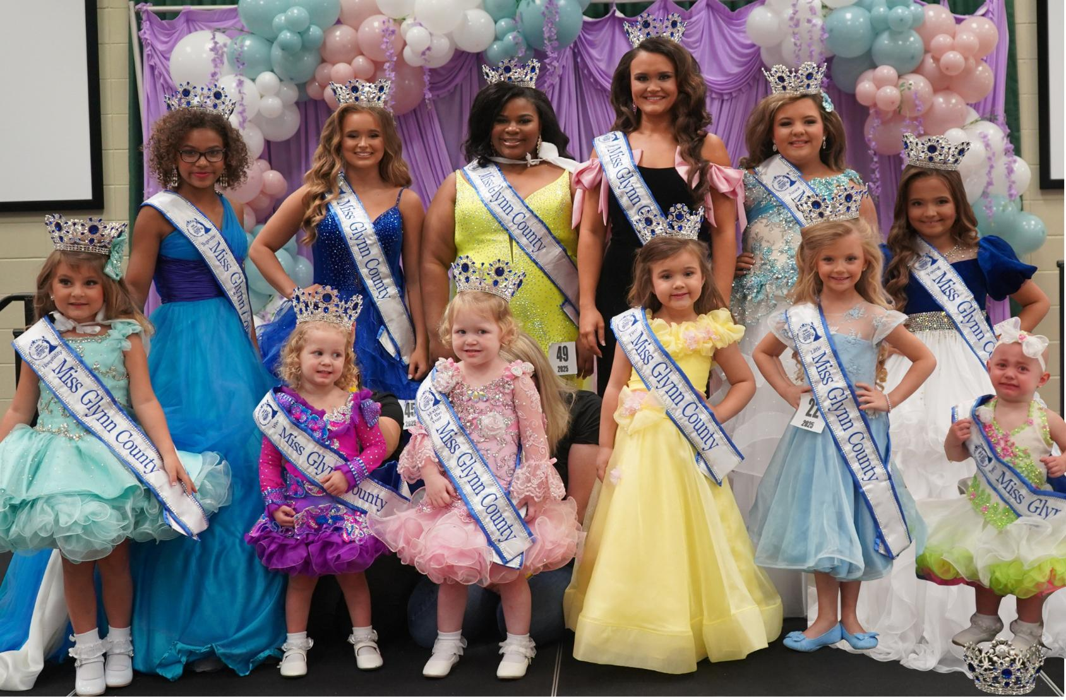

Annual Back to School Pageant
August 2, 2025 JW Turlington School, NC
116 W Prospect Ave #2, Raeford, NC 28376
Registration Time: 9am Pageant Begins: 11am Crowning Commence: 3pm

Divisions are:
Tiny Miss (3-4 Years Old) * Little Miss (5-6 Years Old)
Young Miss (7-9 Years Old) * Junior Miss (10-12 Years Old)
Teen Miss (13-15 Years Old) * Miss (16-18 Years Old)
Rules & Regulations:
1- NO POOR sportsmanship is tolerated! All judges’ decisions are FINAL. Score sheets will be given directly after the pageant to the parents. You may speak with the judges after crowning.
2- Cash ONLY at the door for admissions. You may also pay with a Venmo, Zelle, or Cash App. If you need an invoice please email or message us for an invoice to be sent to you. No refunds unless the event is cancelled.
3- Professional Cameras ARE NOT ALLOWED, but camera phone photos are accepted. A professional photographer will be on hand for all photos. Queens must stay after crowning for group pictures and individual photos for website and advertising for next year’s event. Our Local Hoke Queens MUST SIGN contracts after crowning.
4- Queens are required to make a minimum of 3 LOCAL HOKE CO events in order to receive their scholarships. Those events will be given out online via email. Hoke Co Queens will receive scholarship money at crowning 2026. 1 parade entry in the local Hoke County Fall Festival or Christmas parade & at least 2 other local appearances wearing your crown & sash, is Mandatory to receive scholarships. IF YOU ARE UNABLE TO ATTEND THE REQUIRED EVENTS DO NOT ENTER. 10 Total volunteer hrs including posting/sharing online a min of once a month. You must wear solid white dresses for parade float, not ivory or off white. You MUST return to crown in order to receive scholarship money.

5- Contestants must compete in the age group they are on the day of the pageant. No fallback.
6- Must have a minimum of 25 contestants to award full scholarships.
7- ALL balances must be paid in full by July 16th . You may enter optionals etc… at registration.
8- Lineup based on order of those who pay in full first & fill out the Jot form.
9- Contestants must be natural born female. All contestants must be of good moral character, free from arrests and never convicted of a felony or offense.
10- Only 10 per group will be allowed. After a group is full, you will be placed on the waiting list.
**All winners from 3-18yrs will be REQUIRED to attend the crowning during the pageant and you will be announced on stage. Please bring a nice formal dress in the event you win. Crowning will be in your beauty dress with crown & sash.
*Admission : $5 Ea ages 5 up. Contestant ONLY free with 1 adult chaperone backstage or in dressing area.
Titles and Awards:
Appearance: 3-10yrs old long or short dresses. Light makeup and light tans are ok. Hair should look natural not stiff or overdone. Think age-appropriate. Ages 10-up: Long dresses, hair/makeup/tans are ok. We are looking for a beautiful face, personality and confidence. There are no attire scores. Only face & personality. Pageant or Sunday best dresses.
Talent: Optional Category. Performance must be less than 2 mins. Email song of choice to :info@misscarolinaroyalty.com
**All Scholarships given at crowning during our 2026 Annual Back to School Event**
Scholarships will be raised to $250 for groups with 10 or more contestants.
Ultimate Grand Supreme Miss Carolina Royalty: Queen receives a full round crown, a beautiful flower bouquet, custom embroidered sash, and an educational scholarship (upon returning to crown the following year) The 1st, 2nd, 3rd & 4th runners up receive a sash, and special placard.
Highest Overall Queens: Receives a crown, trophy, custom embroidered sash.
The 1st, 2nd, 3rd & 4th runners up and ALL participants will receive a goody bag and a participation crown.
People’s Choice Winner- People’s choice Queen will be determined by the contestant who raises the most money by selling advance tickets, good luck wishes, or donations. Winner will receive a trophy and crown. 1 per age group. Must sell a minimum of 25 wishes and turn in before crowning ALL who sell a minimum of 300 tickets will receive a 6 ft trophy! If you are going for this we must have your money no later than July 31 to order a trophy. Sell the MOST tickets and receive the Hoke Co Carolina Royalty Hospitality title! Keep selling up until crowning.
Scoring:
Little Miss Contestants will be scored on Facial Beauty (1-25 pts) Personality (1-10pts)
Miss Contestants will be scored on: Facial Beauty (1-25 pts) Appearance (1-10pts) Stage Presence (1-15 pts)

Mandatory Categories Judged:
- Back to School Outfit of Choice/Casual Wear
- Future Me:Dress up as what you would like to be when you grow up. Contestant will be asked why he/or she chose that profession.
- Formal Wear/Sunday Best
Optional Category: Talent Performance (Must be less than 2min long)

Pageant Entry Fees:
(No entries accepted after July 31)
Individual Entry Fee Information:
Entry Fee Deposit : $ 60 If You Would Like to Run for the additional titles below, you must pay for each category
OPTIONALS: Photogenic (1 photo) $10 ______ Prettiest Face: $10____ Best Smile $10_____ Best Hair $10 _______
Prettiest Eyes $10 ______ Best Back To School Outfit (OKC) $10_____ Best Talent $10_____ Best Future Me $10_______
****(Enters contestant into all side categories) AND the highest title: Ultimate Grand Supreme Title: $80
****Enter ALL optionals for $60 _______ (savings of $20) includes ALL above events & up to 2 photos! Photos need to be natural, a minimum of 5x7 max of 8 ½ x 11 labeled with name & age group on back do not mail photos bring these to the registration table at check in.
Want to win the BIGGEST crown ? The contestant who brings in the most back to school supplies will win this category. The contestant will be asked for the name of the school of choice to donate to. You will be asked to take a picture of the table with all of the school supplies that will be donated.

Total Amount $______________________
Payments Options:
Paypal: https://www.paypal.com/donate/?hosted_button_id=BQNBTHR8X6UME
or Venmo: misscroyalty
~If Sending Payment Digitally, please include the Contestant’s Name and Age in the memo/note section
~Print off the last page (EMCEE SHEET) and bring it with you to turn in at registration

EMCEE Sheet Contestant Information- This will be read during the walk on stage
Brothers/Sisters: ___________________________________________________________

Hair Color:_____________________ Eye Color:______________________________

School:___________________________________________________________________

Favorite Subject:____________________________________________________________

Clubs/Activities:_____________________________________________________________

Hobbies:__________________________________________________________________

Pets: _____________________Favorite TV Show:__________________________________

Favorite Entertainer:________________________Favorite Color:_____________________

Favorite Book:_____________________________Favorite Food:_____________________

Favorite Restaurant:________________________________________________________

Future Plans/Ambitions:______________________________________________________

Person(s) You Most Admire:___________________________________________________

Three Words that best Describe you are: ____________, ____________, ______________

Something interesting about yourself or special accomplishments or honors:________________________________________________________________________________________________________________________________________________________________________________________________________________________

** By signing below I agree to adhere by all rules and regulations set forth in the paperwork above.**

Parent/Guardian Signature____________________________________________Date___________

